

Project Management
Economic Study
Economics
Economics is the social science that studies making choices subject to constraints. Project, program, and portfolio managers make economic decisions daily. We try to maximize value delivery subject to the constraints of time, cost, quality, risk, and resource availability.

Economic Study
The economic analysis of any project requires that one estimate both the costs and the benefits from the project through time. Costs include both the initial investment and the annual maintenance and repairs.
Main Purpose
The purpose of economic analysis of projects is to examine and compare various investment options and make investment decision from the viewpoint of economic returns from the projects. Maximize outcomes and minimize costs.

Types of Economic Study
- Cost-Effectiveness Analysis (CEA)
Compares Project Costs vs Actual Costs
- Cost-Utility Analysis (CUA)
Analyses the overall impact of the project (utility)
- Benefit-Cost Analysis (CBA)
Analyses the monetary aspect of Benefit vs Cost.
- Cost-Minimization Analysis (CMA)
Analyses the cost reduction by implementing the project.
The Studies of Economics
At the most basic level, economics attempts to explain how and why we make the purchasing choices we do.
- Scarcity & Choice
- Supply and Demand
- Costs and Benefits
- Incentives
- Sustainability

Project Manager role in Economics/Finance
Project Managers also play a significant role in finance task management, meticulously overseeing expenditures and ensuring alignment with the financial framework of the project. This requires not just vigilance but also adaptability, as they navigate through market changes and unexpected financial challenges.
The purpose of economic analysis of projects is to examine and compare various investment options and make investment decision from the viewpoint of economic returns from the projects.
The avoided cost method would be used if the project were to reduce costs incurred before the project was implemented.

Feasibility Analysis (main 3)
- Internal Rate of Return (IRR)
- Present Net Worth (PNW)
- Benefit-Cost Ratio (B/C)

Additional (optional)
- Return Of Investment (ROI): This is optional as it is an additional method of analysis. The reason why this is not mandatory and is not part of the Main 3 options, is because this option is not as accurate as the other 3. The reason for this is that the ROI analysis does not consider the Value of Money in Time.
Internal Rate of Return (IRR)
The internal rate of return (IRR) is one measure used by economists to evaluate investments. It is based on the principal of discounting which is where future values are brought to present values based on some discount rate. The IRR method seeks to find that discount rate whereby the present value of future returns just equals the initial investment cost.
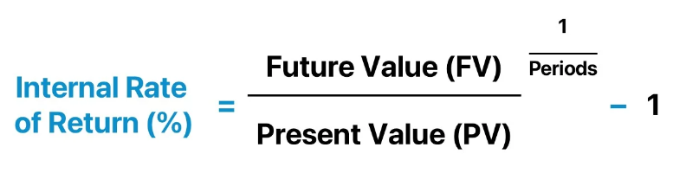
Present Net Worth (PNW)
Present Net Worth (PNW) is used to determine if the benefits, or income, are greater than the costs when both are valued in currency (money: ex. USD, MXN). The method requires that future values are discounted to a present value and added together.
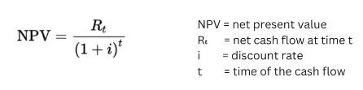
Benefit-Cost Ratio (B/C)
The benefit-cost ratio (B/C) is used to compare the present value of all benefits to the present value of all costs. The ratio is merely used to see if a $1 of costs will return at least $1 in benefits.

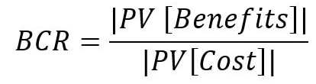
Return On Investment (ROI) optional
A calculation of the monetary value of an investment versus its cost. The ROI formula is: (profit minus cost) / cost. If you made $10,000 from a $1,000 effort, your return on investment (ROI) would be 0.9, or 90%.



INTEREST RATES CALCULATION (FORMULAS):
- Simple Interest: is calculated on the principal, or original, amount of a loan.
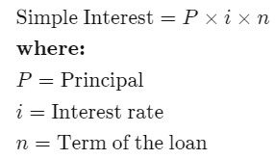

- Compound Interest: is calculated on the principal amount and the accumulated interest of previous periods, and thus can be regarded as “interest on interest.”
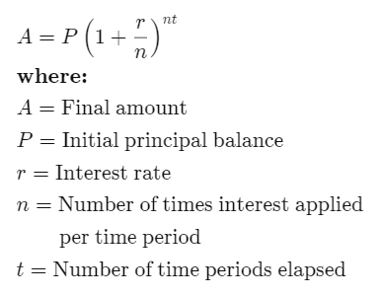

Money in Time variables:
- Inflation
- Rate of Exchange
- Interest Rate (opportunity cost)



